**Grafana Dashboard with MySQL**

**Objective:**

The primary objective of this setup is to establish a robust and scalable monitoring solution for server performance metrics by integrating MySQL as the data storage layer and Grafana as the visualization and alerting platform.

**Steps I Performed:**

Step 1 – Created Database & User in MySQL

* Created a new database named grafanadb.
* Created a user Grafana.
* Granted necessary privileges.

Step 2 – Created Table for Server Metrics

* Designed a table server_metrics_dummy to store CPU, memory, and disk usage with timestamps.

Step 3 – Inserted Sample Data for Testing

* Added dummy server metrics to simulate real-world monitoring.

Step 4 – Configured Grafana Data Source

* Opened Grafana → Connections → Data Sources → Added MySQL.

Step 5 – Created the Dashboard

* Added a Time Series panel.

**Visualisation:**

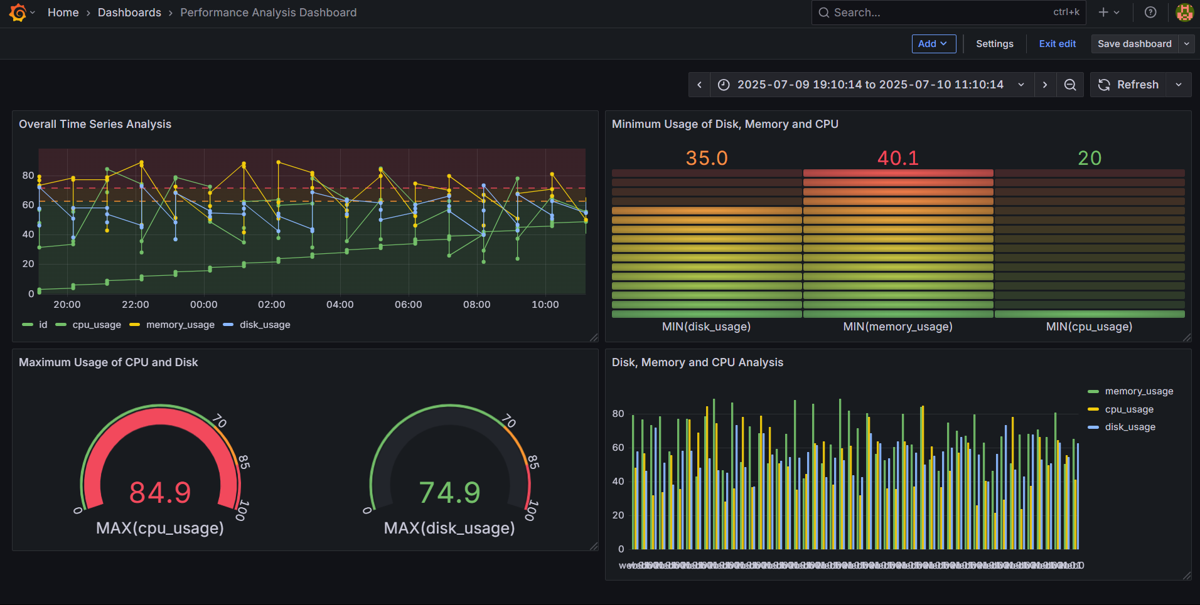

Fig: Grafana Dashboard of performance metrics